“God Wants Your Life to Be a Success – NOT a Mess!”
Dr. Kenneth Hammonds, Personal Success & Leadership Coach

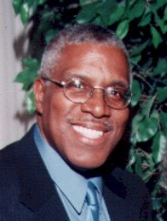Dr. Hammonds is a dynamic professional speaker and a personal success and leadership coach. He is founder of Kenneth Hammonds Success Enterprises and his coaching company called Metanoia Coaching & Training Systems. (Metanoia is a pronounced meta-NOI-a. It is a Greek word that means a radical change in thinking; a shift in attitude). He is a Certified Success Coach who specializes in Personal Development and Leadership & Ministry Development. He is also a New Testament Greek Trainer and Workshop Provocateur.

Dr. Hammonds implements training programs for large and small organizations and delivers provoking and motivating presentations for the workforce of businesses. He also conducts in-depth assessments and training programs for managers and executives.
Dr. Kenneth Hammonds
“The Success Coach”

- Church Leaders Development
- Church Staff Development
- Personal Coaching For Pastors
- Personality Style and Leadership Assessments for Pastors and Church Leaders
- Personal Development and Success Coaching and for Churches & Ministry Staff

Dynamic Workshops, Seminars, and Presentations
Listed below are some of the more popular presentations from,
“The Christian’s Success Coach.”

Programs for Church congregations

Testimonial: “ Well, you said that taking that workshop in Chicago for an hour would change my life, it did.” Dr. M. Paige

Creating Wealth God’s Way
This Christian Wealth Building System is designed to help Christians develop a “wealth mindset” and enjoy wealth in every area of their lives. It is based on the book by Dr. Hammonds entitled, God Wants You to Be Wealthy. This wealth system assists Christians in understanding how to utilize God’s Wealth Cycle for personal and financial wealth.

God Wants Your Life to Be a Success – NOT a Mess!
A thoroughly biblical Christian Success Life Building System, using 7 Life Changing Foundations for Success AND 12 Core Disciplines of Truly Successful People. The 12 Disciplines (12 CD) help people to perform better personally and professionally, and enjoy life more consistently.

Programs for Church Leaders and Staff
Bishop Charles E. Blake, pastor of the 18,000-member West Angeles Church of God in Christ says below regarding the ministry of Dr. Hammonds:

“For 17 years Dr. Hammonds has served this organization with distinction and dignity; and he has been instrumental in teaching and developing thousands of individuals to grow and fully develop in the area of their God-given calling. His innovative and creative ideas helped to propel our rapid growth here at West Angeles.”

Perfecting Christian Leadership Program (PLP)
This is a FULL SCALE leadership program focusing upon leaders perfecting personal skills, people skills, time management and goal setting skills, and professional and Christian leadership skills. Included as a part of the PLP Program are the EQ and the Behavioral Personality Profile Assessments.

This leadership program is designed to assist your church leaders and workers to be more productive in ministry and life. It shows your leaders:
  - How to understand and lead people of different personalities
  - How to be a visionary leader: upholding and enhancing a pastor’s vision
  - How to set goals and achieve ministry objectives
  - How Christian leadership differs from other types of leadership
  - How to develop and personality style that people will want to follow

Understanding and Fulfilling the Mission of Your Church
A church-wide self-assessment program of 10 Probing Questions for congregations or church leaders, based on the 5 Key Questions of the Peter F. Drucker Foundation Assessment Tool for non profit organizations. Dr. Hammonds is a Trained Facilitator by the Drucker Foundation. Also, Dr. Hammonds was Chief Developer & Implementer for West Angeles Church Mission Statement, pastored by Bishop Charles E. Blake

Coaching Employees Toward Excellence Program
A dynamic training program for managers and executives teaching 21 Core Coaching Skills for employee productivity and excellence

Assessments for Personal and Staff Empowerment

- Executive and Staff Personality Profile (Dr. Hammonds is a Certified Personality Profile Consultant.)
- Staff Excellence Program (A program for church paid staff managers and executives seeking to improve their managerial and personal skills.)
- EQ Assessment (Emotional Quotient)
EQ – Emotional Quotient is the ability to deal with and control feelings and impulses.
- Clean Sweep Program (A personal life balance tool that assesses your life in four areas.)

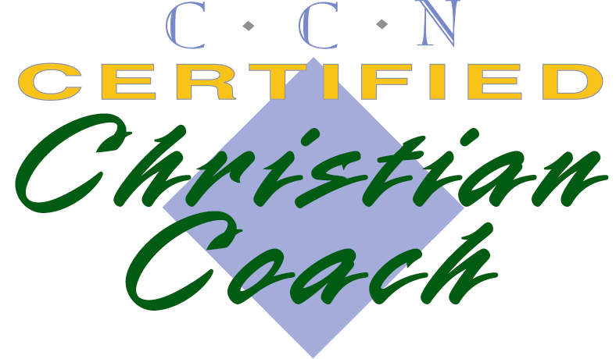
Other Ministry Presentations:

Successful Living Presentations
- Discovering Your Destiny
- Fully Living Your Destiny (The Plan, The Profit, The Money, The Mission)
- How to be an Attractive Person: Christian Principles of Attraction (How to attract the right people, opportunities and money into your life.)
- 7 Reasons God Allowed You To Be Born

Men’s Ministry
- How to be a Marrying Kinda’ Guy
- Men as Lovers (A Men’s Spiritual Development Seminar)
- The Focus of a Man’s Life
- Men Fully Living Their Destiny

More workshops are available or can be designed by request.
Dr. Kenneth Hammonds,
BA, M.Div., Ed.D. Personal Success & Leadership Coach
Kenneth Hammonds Success Enterprises
P.O. Box 2853 Inglewood, CA 90305-0853
Web Site: khammonds.com Book Web Site: WealthyThinking.com
Email: KH@WealthyThinking.com Coaching Phone: 323-753-1366

